**GAUSSIAN NB :-**

Special type of Naive Bayes algorithm, used for continous feature values. It is also assumed that all the features are following a gaussian distribution.

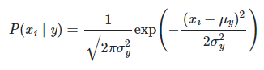

The output of the Gaussian NB in the program 1 is “Virginica”. It correctly classifies the species. The accuracy of Gaussian NB is higher than multinomial and Bernoulli.

**MULTINOMIAL NB :-**

Multinomial NB is a type of Naïve Bayes algorithm, suitable with discrete features. Normally it requires integer feature counts.

The output of the MULTINOMIAL NB in the program 1 is “Virginica”. Multinomial Nb cares about counts for multiple features that occur. It correctly classifies the given data in to the virginica.

**BERNOULLI NB :-**

It is used when the features are only in binary nature (0 and 1). Bernoulli NB is mainly used for text classification with bag of words model.

P(x) = px (1-p)x   where x ∈(0,1)

The output of the MULTINOMIAL NB in the program 1 is “Setosa”. The classification result is different from Gaussian and multinomial NB.  It requires samples to be represented as binary-valued feature vectors here the features are not in binary form.